**Challenges-1**

* Run ifconfig/ipconfig/IP and determine the name/id of your primary network interface
* What is your primary interface's IP address? **10.0.2.15** Is it different from your public IP? **Yes**. Why or why not? **Each computer is unique IP address within the network. The network creates a different IP address as it go through the network.**
* What is the MAC address of your primary interface? Fe80::a00:27ff:fec5:dic
* Identify and understand your loopback interface. **The loopback interface is how your computer communicates with itself and run diagnostics on your computer**.
* 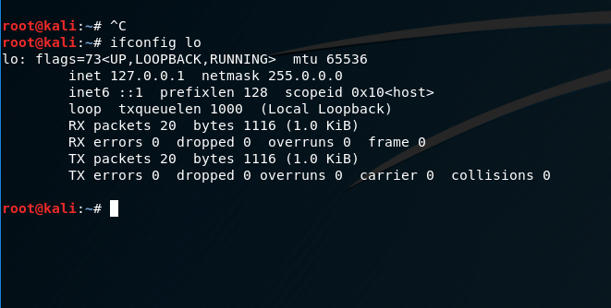

**Challenges-2**

* What is the IP address of codepath.com?**198.58.125.217**
* What is the IP address of google.com? **216.58.216.14**
* Why would the IP address of google.com change between runs or from different locations? **Any webservice that is highly available to multiple instances of computer running multiple application will generate a new IP address.**

**Challenges-3**

* Using the IP for codepath.com from the previous, pass it to nslookup.
* 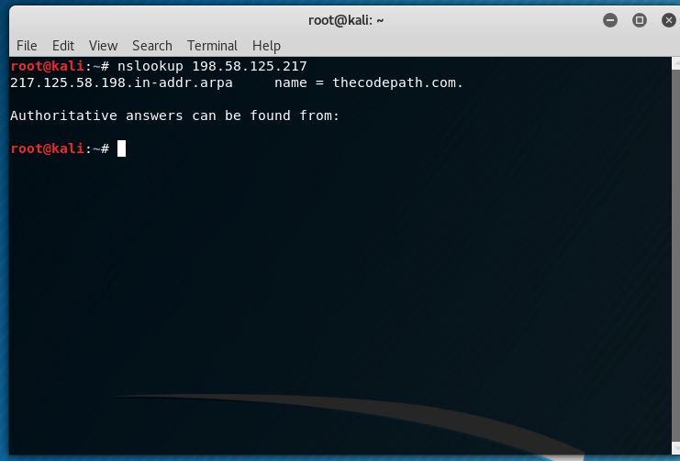
* Does the domain return from nslookup match? If not, why not? **No the domain didn’t come back matching, because the static IP address keep changing as it is being ping**.

**Challenges-4**

* What's one thing that makes telnet insecure? **The session between the client and the server is not encrypted.**
* Can your telnet to codepath.com? What port is open and why? **No unable to connect through telnet on port 23. No ports open.** 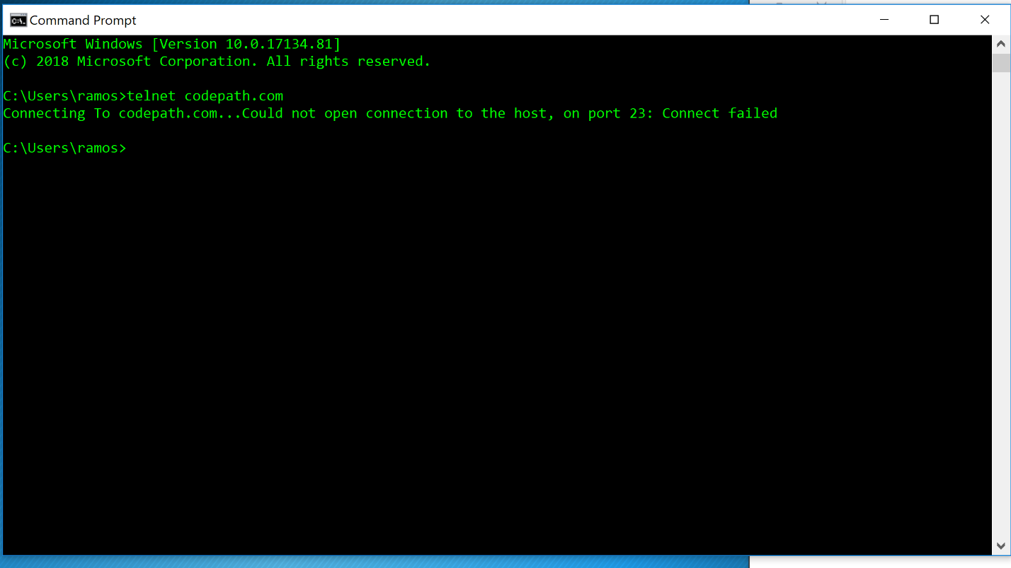

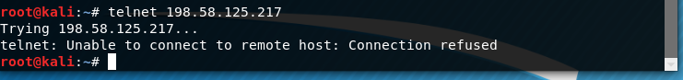

**Challenges-5**

* Identify some differences between the two. **CURL can send files information through the URL syntax, were as WGET retrieves content from web servers.**
* Which would you be more likely to use for interacting with a RESTful API from the command line? **Curl is the command line I would use because the tool that is available on major operating systems.**
* Which support recursive downloading? **WEGET, because it is an application to download content from the websites.**
* Which are you more likely to find pre-installed on a Linux OS? **Curl is pre-installed on Linux OS.**
* What is the syntax for each for downloading a file to the current directory? **wget -O /var/cache/foobar/stackexchange-site-list.txt/ http://url.to/stackexchange-site-list.tx**

**Challenges-6**

* Why is key authentication preferred to passwords? **The key lock in the PK and numeric password that it need to authenticate your password.**
* What is the syntax for copying a file from a local folder to a remote one? **scp -r user@your.server.example.com:/path/to/foo /home/user/Desktop/**